Templates

* What do I know about the basic structure of it before I get to the details?
  + Data-driven templates
    - Given that I know what type of data this function consumes, what do I know about the structure of this function
  + Big-bang World program template
    - Given that I know I’m using big-bang, what do I know about the basic structure of this program before I start

-> 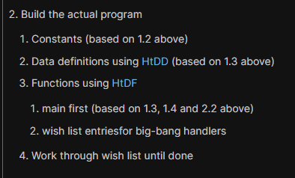

Go to design recipe -> HtDW -> scroll a bit -> copy the Template for a World Program

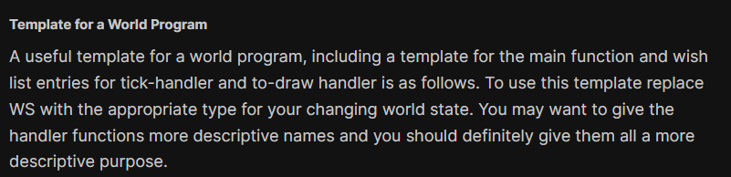

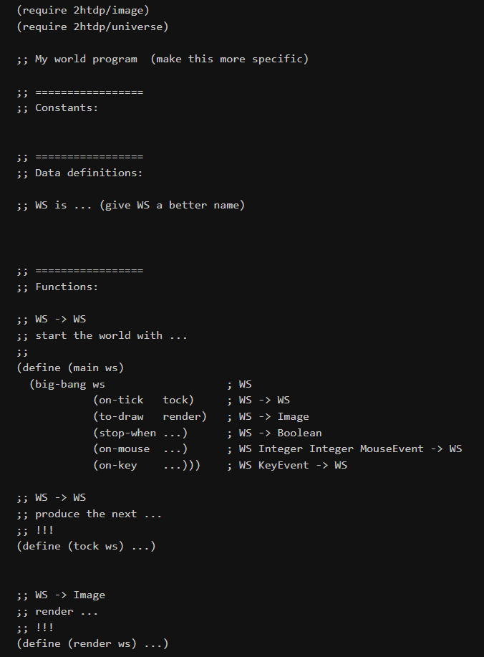

Refactoring the template based on our program

Build the actual program

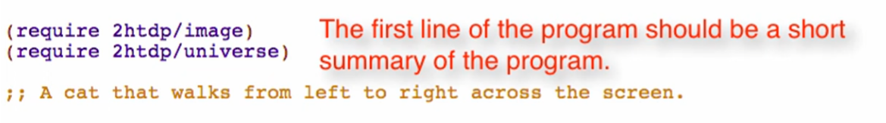

1. Constants

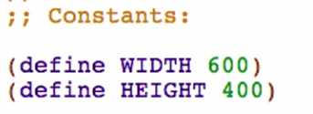

Make the coordinate-y dependent on height so you won’t have to change it every time height will be changed



(empty-scene width height color) – produces a blank background



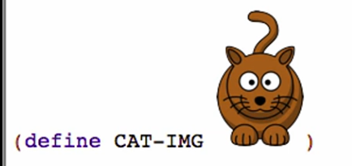

Run to know if there are any errors

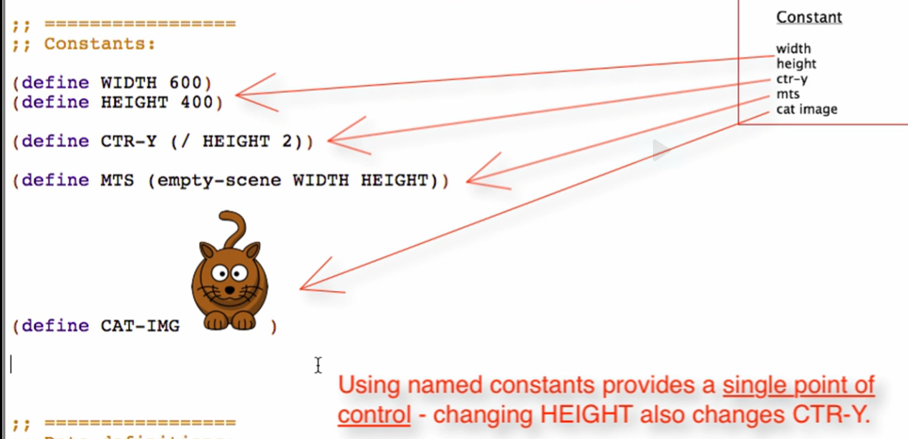

Traceability

* + Ability to see where each analysis element winds up in the resulting program

Important note:

* Any program that has users will HAVE to change
* Users want new features, better performance, etc.
* Being EASY TO CHANGE is one of the most important properties a program should have

1. Data Definitions

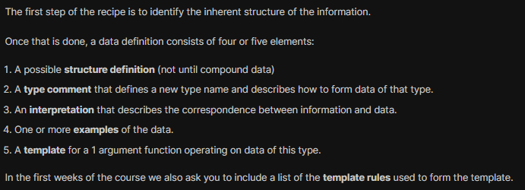

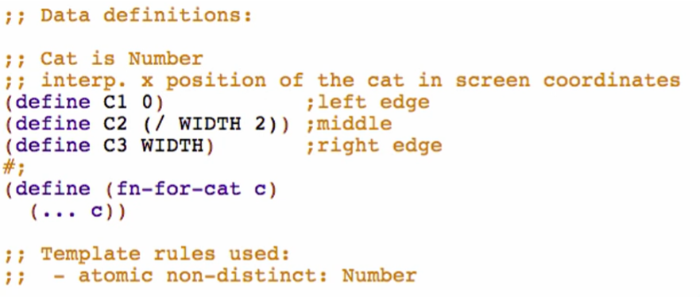

1. Functions
2. Main first

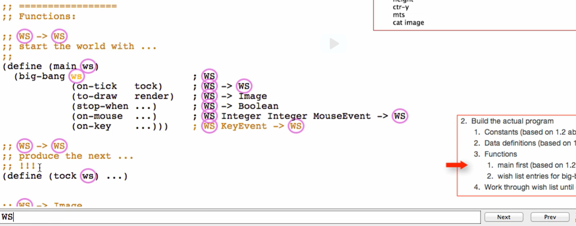

Replace WS with your Data Definition for all comments only for now (exclude parameters)

* + This is to not mess up the template

Replace parameter (ws) to your parameter name

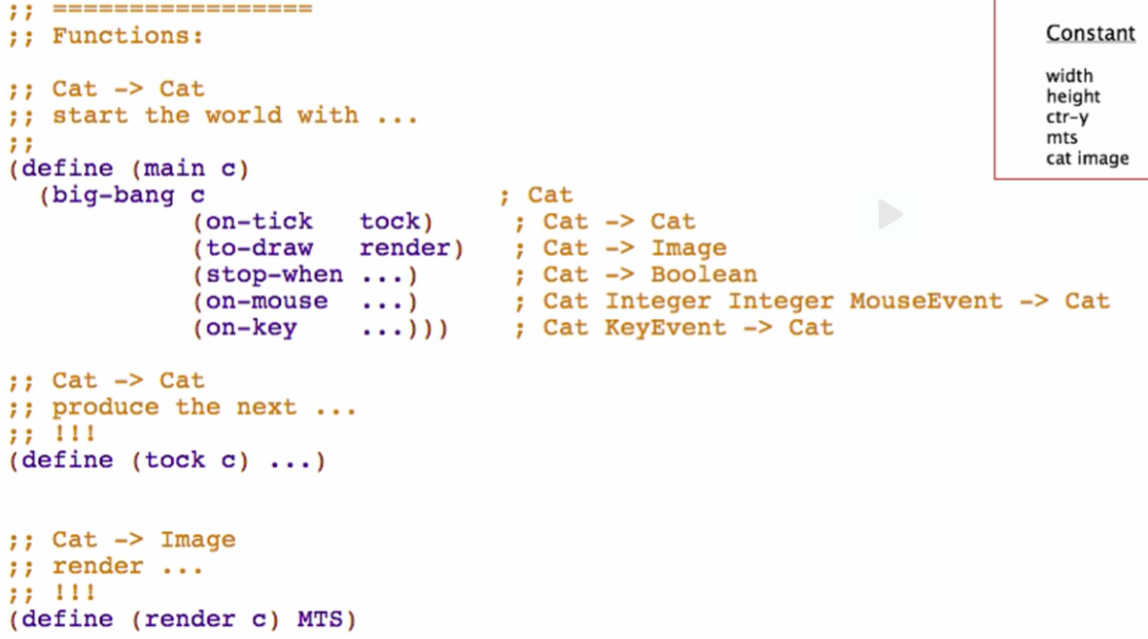

Try running to know if it is well formed

Delete other options that you will not use based on your analysis

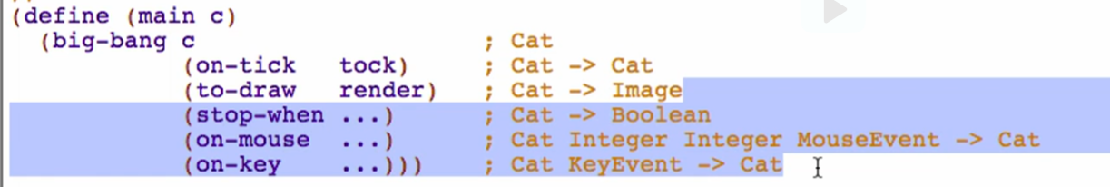

Rename your functions the name you want

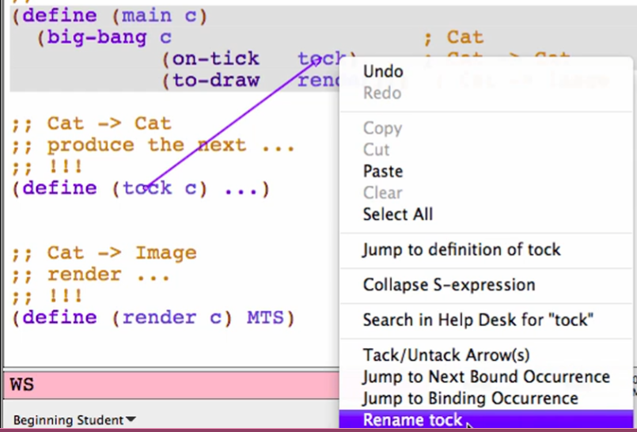

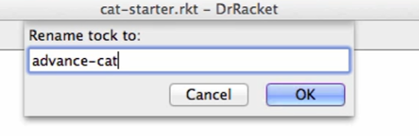

1. Wish list entries for big-bang handlers

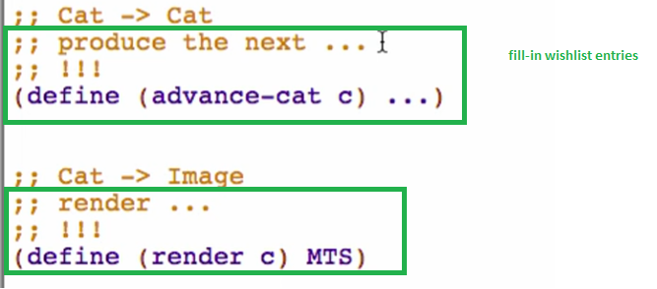

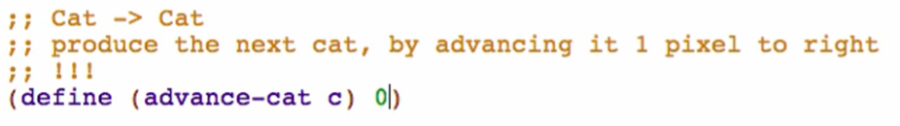

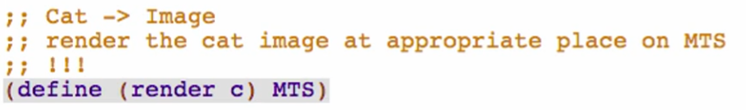

Wish-list entry

* + Has the following:
    1. Signature
    2. Purpose
    3. !!!
       - Marker on what you have to finish later
    4. Stub
       - Allows programs to at least partially run
  + A promise to come back and finish this function later